**LABOUR SEARCH AND MATCHING WITH APPLICATION IN CGE MODELS.**

By Han Sun & Monelle Degbe

Professor: Yazid Dissou

ECO6110

Ottawa, Ontario

April, 2021

Table of Contents

Abstract 3

Introduction 4

Literature review 5

The environment 7

Assumptions and key elements: 7

Unemployment 9

Asset value 9

Wage Bargaining 9

Effects on changing in exogenous variables 10

Comment on the source of data 10

More detailed models. 11

Problems on the calibration 12

The role of Policy 12

Discussion and conclusion 13

References 15

Appendix 16

Figure 1 16

Figure 2 17

Figure 3 17

# Abstract

Abstracts from agent’s behavior and relies entirely on the matching function. The origin of the movements is exogenous. Search-and-matching model integrates optimization behaviors and interactions between agents in the labour market. (Pissarides (1985); Mortensen, Pissarides (1994); Pissarides (2000)). The model predicts, in equilibrium, a dynamic for unemployment, job vacancies, and labour market flows. It provides a framework for analyzing the effect of public policies and the sources of fluctuations in labour market variables. A key assumption of the model is the presence of search frictions which will be discussed in the following section. This model considers unemployment as a consequence of these frictions.

# Introduction

The search and matching theory are a mathematical framework that has been used in different disciplines but has been particularly influential in labor economics. The labor search and matching model was introduced in 1994 by Mortensen and Pissarides (MP), (they won a Noble prize for their foundation work on the model), it integrates optimization behaviors and interactions between agents in the labor market and is characterized by a potentially large amounts of job creation and job destruction, due the idiosyncratic shocks that take place. (Mortensen, Pissarides (1994)). The MP model has a matching function and a Nash bargaining; it predicts in equilibrium, a dynamic for unemployment, job vacancies, and labor market flows. The model provides a framework for analyzing the effect of public policies and the sources of fluctuations in labor market variables. A key assumption of the model is the presence of search frictions and unemployment is considered a consequence of these frictions. In recent years, the Mortensen-Pissarides search and matching model has become the standard theory of equilibrium unemployment. The model is attractive for a number of reasons: it offers an appealing description of how the labor market functions; it is analytically tractable; it has rich and generally intuitive comparative statics; and it can easily be adapted to study a number of labor market policy issues, such as unemployment insurance, firing restrictions, and mandatory advanced notification of layoffs.

However, the model although accepted by the majority has also been challenged and discussed in multiple literatures. Those researchers argue that although the MP model outperforms the standard real business cycle (RBC) model with no labor market frictions (Merz (1994), Andolfatto (1996)), it fails in explaining the strong cyclicality and persistence of key labor market variables such as vacancies, unemployment and job creation (Shimer (2005).

In this presentation, we will be explaining the model further and presenting it from a different angle that includes a CGE framework for further analysis of the frictions in the job market. Because the computerized general equilibrium (CGE) is a model that is not usually used in labor economics, (for the simple reason that it forces the researchers to make more complex market clearing assumptions), exploring the usage of that model here, will bring additional insight to the topic. In that light we will be focusing our discussions on the two following papers of study: “Equilibrium Unemployment Theory” by Christopher A. Pissarides (2000) and “The Labor Market in CGE Models” by Stefan Boeters and Luc Savard (2011). First, we will give the state of the literature on the topic, present the model, explain the key assumptions and some questions that the model resolves, the data and the calibration, and finally, present and discuss the results before concluding.

# Literature review

The labor search and matching model plays a growing role in macroeconomic analysis and has been well documented in the literature. A number of high-quality datasets that track the model’s observables have also become available in recent years and have enabled important empirical work based on investigations of the model’s predictions and the implications of their success and failure. It has been used in different analysis, discussed, and modified to answer specific questions.

Indeed, before the search and matching model, there were limitations with the existing neoclassical model, which is a basically static model, element of the standard RBC (**Real business-cycle) theory**. The neoclassical model required a high labor supply elasticity that would generate the empirically observed high variability of hours worked together with low real wage variability and that was hard to justify. Therefore, M&P’s model came in play when the need to have explicit dynamic, stochastic, intertemporal optimization by firms and workers in the labor market segment of the macroeconomic model, arised. (**Yashiv, 2007).**

Shimer (2005) reports that Mortensen-Pissarides search and matching model is attractive for a number of reasons: it offers an appealing description of how the labor market functions; it is analytically tractable; it has rich and generally intuitive comparative statics; and it can easily be adapted to study a number of labor market policy issues, such as unemployment insurance, firing restrictions, and mandatory advanced notification of layoffs. In the same sense, Yashiv 2007, adds that the model places emphasis on the flows between labor market states — employment and non-employment — and allows for a dynamic steady state. Like other key models in modern macroeconomic theory, it features optimizing agents, rational expectations, and equilibrium outcomes. All those features allow it to be readily used in frameworks like RBC, New Keynesian, and growth models and that is what makes it so widely used in the world of labor economics. Furthermore, modifications to the search-and-matching model allow it to explain numerous other phenomena. Instead of workers being only either employed or unemployed, non-employed workers can be allowed to exit the labor force entirely, to go on disability, or to remain in traditional unemployment (that is, receiving unemployment insurance while searching for a job), or enter some other unattached state. What the search-and-matching theory has, and what its alternatives lack for the most part, is *indeterminacy* about how wages are set. The “Nash Bargain” theory is optimal, but it is not necessary—other wage-setting assumptions can be used to resolve the indeterminacy. And if economists can get their minds around the idea that the “market solution” is not always optimal then they can make real headway with the search-and-matching approach precisely because it is consistent with those alternatives. (Steinbaum,2014).

However, the Motersen-Pissaride search and matching model is not perfect. Shimer (2005) argues in his paper that, the model cannot explain the cyclical behavior of two of its central elements, unemployment, and vacancies, which are both highly variable and strongly negatively correlated in U.S. data. Steinbaum (2014) goes in the same direction arguing that in addition to the unability of the model to account for some of the cyclical facts, there is evidence against the Nash solution used for wage setting in the model. Therefore, although the MP model outperforms the standard RBC model with no labor market frictions (Merz (1994), Andolfatto (1996)), it fails in explaining the strong cyclicality and persistence of key labor market variables such as vacancies, unemployment, and job creation (Shimer (2005a), Fujita (2003)).

The simplicity of the assumptions in the search and matching model as well as in a lot of other labour economics model makes us wonder whether an approach using a more complex modeling method help us better analyze the consequences of certain policies on wage and unemployment. About that**, Boeters and Savard (2011)** argue that even though it is possible to use a CGE modeling to analyze the effects of some policies shocks on the labour market, there is a need for a certain level of labor-market complexity, the modelling and calibration is still very demanding and there is a need for a stronger framework. Also, they advice that when using CGE it may be better to adopt a question-driven approach and see the model as a tool to answer specific questions, it is also important to clearly determine the initial shock we are analyzing, the labour supply and demande specification, and whether to iterate a micro model with the macro module or engage in one-way linkage. Also, if we want to develop a CGE model starting from the default option of almost all first-generation CGE models market-clearing wages in a single labor market we can in principle develop in two directions independently: more complex mechanisms, say endogenous unemployment, at the same level of aggregation, or the same, simple mechanism at a deeper level of disaggregation. As for the search and matching model, Pissarides (1998) and Sørensen (1999) show how the most prominent options of modelling unemployment search and matching, efficiency wages and collective bargaining are calibrated and implemented in a simple CGE context. Search-and-matching models exist in a vast number of varieties, which is partly because they lend themselves conveniently to empirical estimation with micro data. However, only the simplest of these varieties have been used in a CGE context.

# The environment

# Assumptions and key elements:

This section is mainly used Pissardes’ (2000) **“**Equilibrium Unemployment Theory”.

An economy in continuous time, populated by workers and producers. Workers are endowed with an indivisible unit of time which can be supplied in the labour market. There is a mass of firms produce a consumable good with access to a linear production technology with a time discount rate using labour input as numeraire where is endogenous and determined by labour market equilibrium. This is important to have a linear production technology, because of linearity, considering the sum of individual behaviors is equivalent to considering the aggregate behavior. And the population of firms is also endogenous that determined in equilibrium. The labour market features search and matching frictions, which impede the meeting of supply and demand. Workers are either employed or unemployed. Firms hold jobs either vacant or occupied. The number of jobs created during a small-time interval, and the fraction of jobs destroyed in each period designates the Poisson rate of job destruction. The cause of these job losses is considered to be exogenous.

p( $θ)δ≡\frac{m\left(u,v\right)}{u}δ=m\left(1,θ\right)δ;$ (1),

q($θ)δ≡\frac{m\left(u,v\right)}{v}δ=m(\frac{1}{θ},1)δ$. (2),

p’($θ$)>0, q’( $θ)<0.$ p($θ$)= $θ$ q($θ)$. (3),

It is necessary to define some equations here, m (1) is the matching friction which value determines the number of matches per unit of time and depends on unemployment rate and vacancy rate. The format of this matching friction can be given as either Cobb-Douglas, CES or something else. Theta refers to the labour market tightness. P and q (2), (3) refer to the transition probability which are independent of the total population. The unemployed and vacancies are matched according to a matching technology (described by a function m) that governs agents’ meeting in labour market. The total population of labour force can be increase, decrease or remain in constant. The probability for an employer with a vacancy to meet a worker is the associated Poisson rate and the probability for an unemployed individual to find a job during a small-time interval refers to the Poisson rate at which unemployed workers move to employment refers to the labour market tightness. Workers and firms meet randomly in the labour market due to the presence of search frictions.

$U\left(t\right)=bδ+\frac{1}{1+rδ}[p\left(θ\right)δW\left(t+δ\right)+\left(1-p\left(θ\right)δ\right)U\left(t+δ\right)]$ (4),

$W\left(t\right)=wδ+\frac{1}{1+rδ}[(1-λδ)W\left(t+δ\right)+δλU\left(t+δ\right)]$ (5),

$V\left(t\right)=-cδ+\frac{1}{1+rδ}[q\left(θ\right)δJ\left(t+δ\right)+\left(1-q\left(θ\right)δ\right)V\left(t+δ\right)]$ (6),

$J\left(t\right)=z\left(t\right)δ-w(t)δ+\frac{1}{1+rδ}[(1-λδ)J\left(t+δ\right)+δλV\left(t+δ\right)]$ (7),

Workers seek to maximize lifetime utility under the condition that the lifetime utility of an employed worker at time t (5) greater than the lifetime utility of an unemployed worker (4), and any opportunity to hold a job is captured. The firm maximizes the present value of profits and the expected profit in the next period is determined by the probability of finding a job for a vacant position (6) and the probability of job destruction for an occupied position (7). Each value depends on the labour market tightness.

# Unemployment

$\dot{U}=\dot{u}L+u\dot{L}=\dot{L}+λ\left(L-uL\right)-m\left(u,v\right)L$ (8),

$\dot{u}=n+λ-\left(n+λ+p(θ)\right)u$ (9),

$u=\frac{n+λ}{n+λ+p(θ)}$ (10),

The dynamics of total unemployment (8) is given by the rate of change in unemployment is equal to the rate change in the labour force plus the instantaneous flows of workers who lose their job, net of the flows of unemployed who find jobs. The rate of change of unemployment rate (9) can be expressed in the rate of change as a function of the growth rate of the labour force, the rate of job destruction and creation. In the steady state, u dot becomes zero we get an equation refer as Beveridge cure (10) which indicates a negative relationship between the unemployment rate and labour market tightness.

# Asset value & Job Creation

For workers:

$rU=b+p\left(θ\right)\left(W-U\right)$ (11),

$rW=w+λ(U-W)$ (12),

For firms:

$rV=-c+q(θ)(J-V)$ (13),

$rJ=z-w+λ(V-J)$ (14),

By analyze the job creation decision of firms, we have q’<0. Therefore, the function V is strictly decreasing. We can assume that free entry and exit of firms so implies V=0. So, we can eliminate V and rewrite value functions. For example, the first equation for firm (13) will become to:

$r0=-c+q\left(θ\right)\left(J-0\right)⇾J=\frac{c}{q(θ)}$ (15),

Similar with the second one:

$rJ=z-w+λ\left(0-J\right)⇾J=\frac{z-w}{r+λ}$ (16),

then we can set two equations of Js equal (15) & (16) which will provide this job creation condition (17) for us.

$J=\frac{z-w}{r+λ}=\frac{c}{q(θ)}$ (15) & (16),

$z-w-\left(r+λ\right)\frac{c}{q\left(θ\right)}=0$ (17),

# Wage Bargaining

$S=W-U+J-V$ (18),

Finally, we have to determine the wages in order to close the model and characterize the equilibrium. Let’s define the total surplus of a match named S (18) which is equal to the total value of the total value of the two agents, net of their outside options. Recall that U, W are the lifetime utility of an unemployed and employed worker at time t. that I mentioned before. V, J are the expected present value of the lifetime profits associated with a vacant and an occupied position.

$\max\left(w\right)={\left(W-U\right)}^{γ}{\left(J-V\right)}^{1-γ}$ (19),

Wage is determined by Nash bargaining where gamma is the worker’s bargaining power relative to that of the employer. By solving this maximation problem (19), we can obtain such relation and it is easy to decompose out the variable total surplus S alone. Which is the present value of future streams of production flows, net of the returns associated with the agents’ exit options.

$W-U=γ\left(w-U+J-v\right)=γS$ (20),

Combine the agent’s surplus equations with the Nash solution (20) then gives the equation for wage (22) which is a combination of the marginal productivity and the reservation wage. The relative weight of each element depends on worker’s bargaining power. Also, because the wage equation depends positively on the market tightness, we can express wage equation in terms of tightness (23). That three conditions are what we need in a steady state equilibrium in the labour market.

$S=\frac{z-rU-rV}{r+λ}$ (21),

$w=γz+\left(1-γ\right)rU$ (22),

$w=γ\left(z+cθ\right)+\left(1-γ\right)b$ (23),

# Effects on changing in exogenous variables

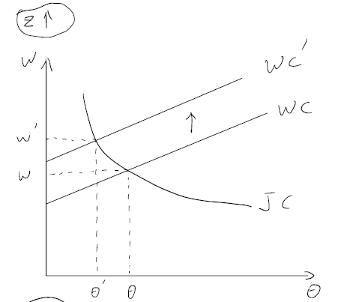 Now, it is enough for us to see the effects of exogenous shock in labour market equilibrium. The change in the productivity of labour, the increase in productivity generates gains that are shared between the worker and the firm, through bargaining; wages and profits increase, which strengthen job-creation incentives and thus the tightness. The unemployment rate declines, due to the resulting increase in unemployment outflow. As result, wages rise, unemployment decrease and vacancies increase.

By the way the matching efficiency is a coefficient in our matching function, just like technology in production function. Decrease matching efficiency, will increase effective hiring costs, leading firms to create fewer jobs given unemployment. The result decrease in market tightness lower wages and increase unemployment. There is an uncertainty on the job vacancies because a positive effect due to higher unemployment which improve search conditions for firms and a negative effect through the decline in matching efficiency. Similar for job destruction rate. The book also shows them in the graphically in chapter one, I will not show them to you here.

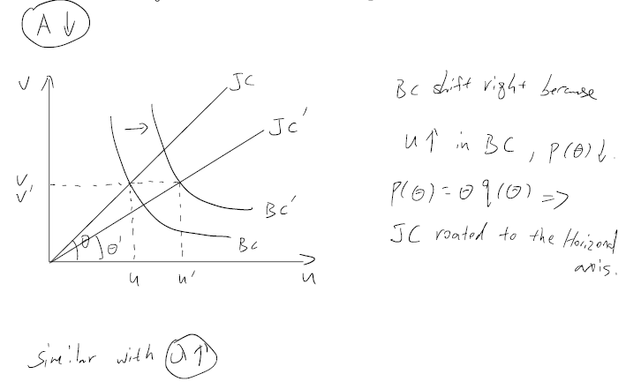

# Comment on the source of data

I will talk about the data and calibration methods base on another paper called “the labour market in CGE models”. When we work with a large number of representative households in CGD model, the basic or first requirement is having elasticities available to calibrate those households in proportion. And those elasticities are participation with respect to the wage, working hours with respect to the wage, and working hours with respect to non-wage income to calibrate a single representative household. With n households, we have a lot of work to do. To solving this, we have two options: first is assuming elasticities are identical for each household, or estimating the elasticities ourselves. The two most common data inconsistency issues are at level of individual income balances which means income does not equal expenditure plus savings, and inconsistency in information about skill type, income shares, etc. the basic model that I introduced before just have the second issue, because the firm hold vacant jobs but don’t know the information about workers. The workers who are unemployed and willing to work will be hired if they are able to match with the firms through the matching function. Workers have full mobility to work in different industries, however, this will not become a problem when we can rewrite the basic model, and make it more complicative. I talk about this later. For the inconsistency in income balance, there’s nothing we can do on the model, but we can still through adjusting data to avoid this issue.

# More detailed models.

The two-level nesting approach has been chosen by Colombo (2008), who has a 222 classification of skill, occupation and gender. By comparison, another paper uses a non-exhaustive cross-classification of formal or informal, three skill types, rural or urban and civil servants in a one-level nesting. In this diagram, we only can see it is similar with the first scenario, but a little difference here: there is not talking about occupation. Either scenario gives us a possibility to build up a detail model that we need for the CGE.

Then we moving to the figure one, I talked about figure 3 last page. Actually, there is a figure 2 exist, which is covered in last page. The figure one is just looks like our assignment two, isn’t it? If we do things like that, instead of too few parameters, we have too many now. There are 26 free parameters at hand which are: six elasticities and four free share parameters for each factor for producing a match between the model and the ten exogenous elasticities. However, it isn’t the end of world, we could still solve it by restricting certain elasticities to one or zero or adding a penalty function.

# Problems on the calibration

Partial derivative on wage curve with respect to unemployment gives wage curve elasticity but only depends on variables: separation, unemployment, and discount rate. Which requires to choose about exogenous variable. Then we are fine now. We are no problem with calibration now. Calibrating the wage curve as a calibration target, and the bargaining power parameter, then we are good to collect result that we need. Why I said the wage is calibration target that is because (the stable relationship between the wage level and unemployment has a wage curve elasticity of -0.1). Also refer to Fujita and Ramey’s paper, there is the cyclical relations between separation and job finding rate. That could seem to be a factor of fluctuation of unemployment rate which will influence our wage rate.

# The role of Policy

The model should allow analysis of the effect of policies on the labour market. This can be useful to study the sources of cross-country differences in labour-market outcomes like effects of employment insurance, minimum wage, taxation and firing costs. In a scenario which the worker has different skill level of productivity, their wages depend on how they able to produce. If the minimum wage higher enough, will lead to a decreasing in participation rate. Because the workers who earn less than the minimum wage will quit their job, and start receiving the social benefit like unemployment insurance then take a leisure. We now turn to a question with normative implications, is the decentralized equilibrium socially efficient? What does this imply for the role of government intervention? Well, that is another long story, and it is possible to apply on the social planner framework, process Euler’s condition or the Hamiltonian like we learned in Macro class. Also, there are something we could talk on the business cycle, but I think it is enough here and I will end my part here.

# Discussion and conclusion

The labor search and matching model introduced by Mortensen and Pissarides (1994), has been a workhorse for economists in the last couple of decades, it was a needed change from existing models and had a big impact on the field. Despite that, it still has major drawbacks that have been and are still being explored in literature. As part of them we can count the fact that the model characterizes unemployment mainly as a transitory phenomenon and downplays long-term, structural effects. Indeed, just as many economic models, the search-and-matching model is a simplification, even a ludicrous one, Quiggin (2014) argues that it fails even as a simplification of reality because the main reason why unemployment exists is not because workers and firms are groping in the dark for one another, a process which just by its nature takes time. There is also the problem of the Nash bargaining and he cyclical facts that were no accounted for in the model, as discussed in the literature review. Multiple papers concluded that the way wage setting has been modelled, using the Nash bargaining solution, is unsatisfactory. The problem is that this theory of wage setting is an empirical disaster. Not only is it inconsistent with investigations into how actual wages are actually set, but it generates false predictions about unemployment spells that crucially fail to line up with what happens to unemployment during recessions (it goes up, and it stays high for a long time, when the optimal theory of wages says that wages should do the adjusting). Refinements that make the theory with Nash Bargaining consistent with the data on unemployment in recessions yield their own big empirical problem: those refinements imply that being unemployed isn’t really that bad for workers, which everyone who is sentient knows to be untrue. This way of modelling has found little empirical corroboration and has proved problematic theoretically too. Therefore, current research focuses on the exploration of alternative wage setting mechanisms. (Yashiv 2007).

About the modelling with CGE, modelling labour market coordination presents itself as a sharp trade-off. Ideally, we would like to have a theoretically founded, structural model of involuntary unemployment, which contains enough free parameters to be calibrated unfortunately, Boeters and Savard (2011) show in their review that such a model is not easily available. Any reasonably simple structural model of unemployment has severe difficulty to be calibrated to empirically plausible wage curve elasticities. Working with these elasticities directly, without a structural foundation, is possible, but reduces our resources of providing an economic interpretation of changes in the wage as a response to policy shocks.

Finally, a lot of other papers results are consistent with our reference papers and others go further and apply search and matching to other areas like taxes and environment policies. For example, the search explanation of unemployment in Pissarides (2000) is consistent with the assumptions of Hansen (1985) and Rogerson (1988) of indivisible labor because the assumption that workers either search or work follows naturally from the existence of indivisibilities. In calibrations, matching models are usually compared with Hansen's calibrated model and shown to perform at least as well. Shi and Wen (1997) integrated the search equilibrium model with capital accumulation derived from an intertemporal utility maximization framework and derived various analytical results, including a hump shaped response of output to a productivity shock.

# References

* Pissarides (2000), Equilibrium Unemployment Theory
* Boeters & Savard (2011), The Labour Market in CGE Models
* Shimer (2005). The Cyclical Behavior of Equilibrium Unemployment and Vacancies;
* Eran Yashiv (2007), Labor Search and Matching in Macroeconomics;
* Montersen & Pissarides (1994), Job creation and Job Destruction in the theory of unemployment.
* Koursaros (2011), The Search and Matching Model: Challenges and Solutions;
* Marshall Steinbaum (2014), The value of search-and-matching models for the labor market;
* Jonathan Crechet (2021), Unemployment and labour market flows;
* Fujita, Ramey (2009), The Cyclicality of Separation and Job Finding Rates

# Appendix

# Figure 1

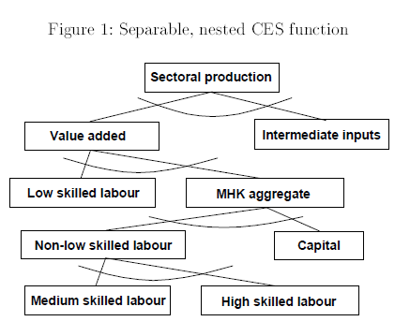

# Figure 2

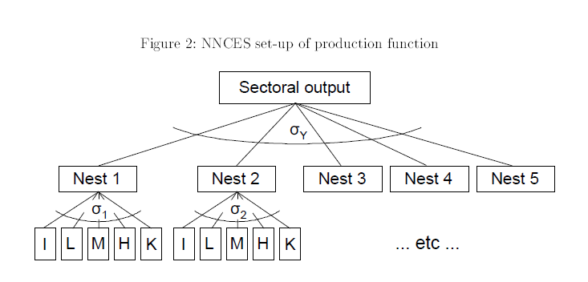

# Figure 3

